Now lets add Next & Previous Buttons in DepartmentDetails Component

Add 2 anchor tags

import { Component, OnInit } from '@angular/core';

import { ActivatedRoute } from '@angular/router';

@Component({

  selector: 'app-department-details',

  template: `

    <h3>

     You have selected {{departmentId}} </h3>

  `,

  styles: [

  ]

})

export class DepartmentDetailsComponent implements OnInit {

  constructor(private activatedroute : ActivatedRoute) { }

  public departmentId : number;

  ngOnInit(): void {

  let id = this.activatedroute.snapshot.paramMap.get("id");

  this.departmentId = id;

  }

}

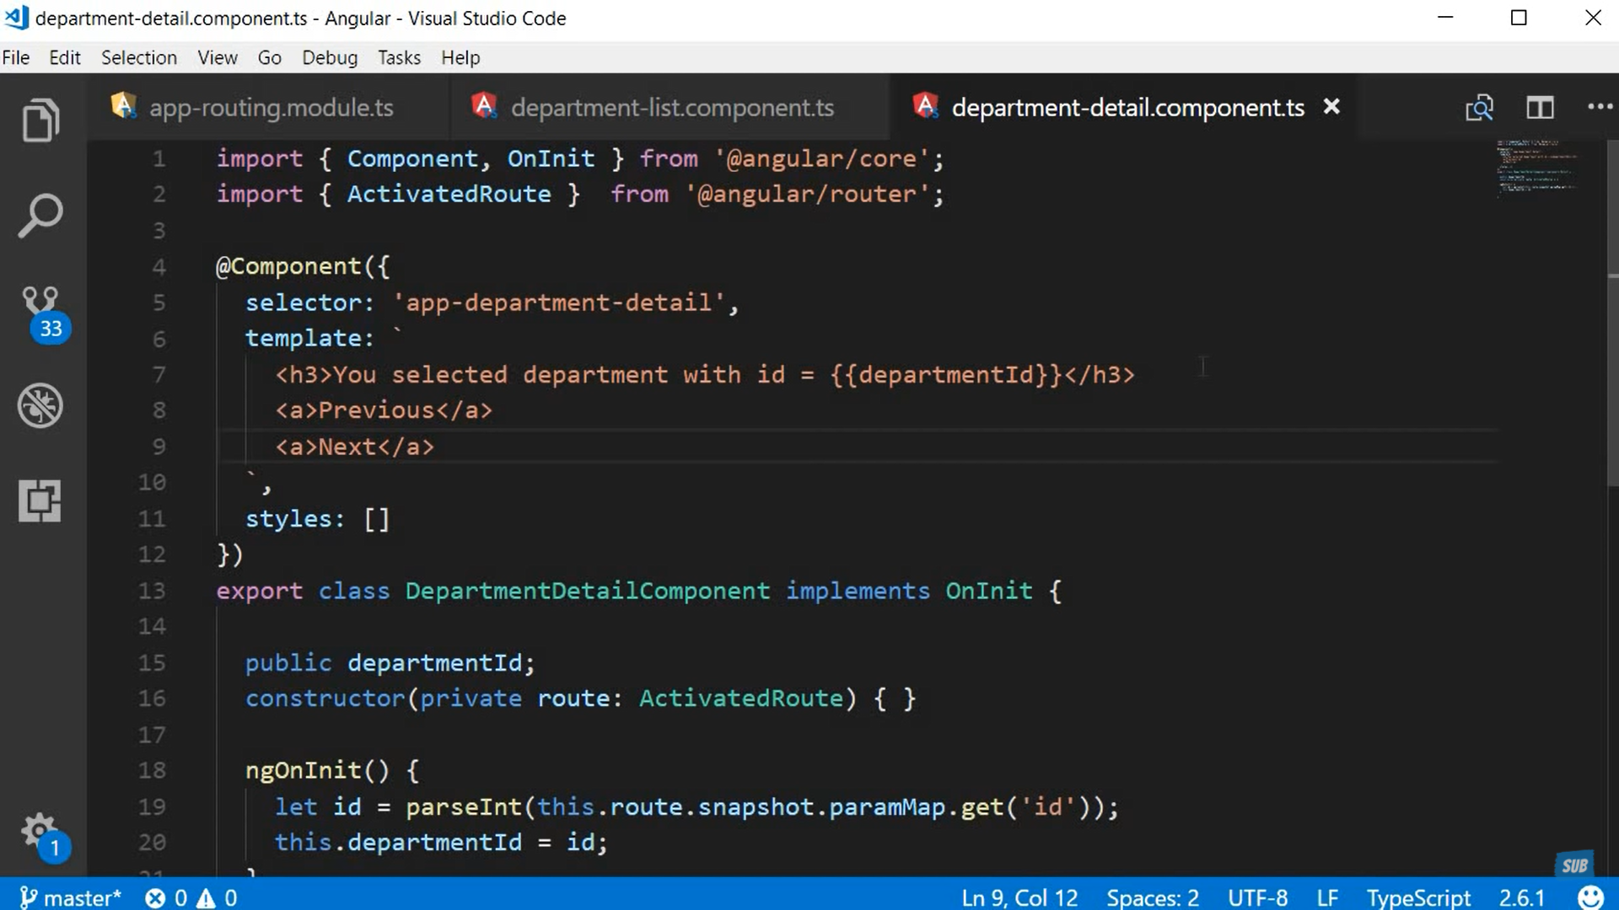

import { Component, OnInit } from '@angular/core';

import { ActivatedRoute } from '@angular/router';

@Component({

  selector: 'app-department-details',

  template: `

    <h3>

     You have selected {{departmentId}} </h3>

        <a (click)="goNext()"> Next </a>

        <a (click)="goPrevious()"> Previous </a>

  `,

  styles: [

  ]

})

export class DepartmentDetailsComponent implements OnInit {

  constructor(private activatedroute : ActivatedRoute) { }

  public departmentId : number;

  ngOnInit(): void {

  let id = this.activatedroute.snapshot.paramMap.get("id");

  this.departmentId = id;

  }

}

import { ThrowStmt } from '@angular/compiler';

import { Component, OnInit } from '@angular/core';

import { ActivatedRoute, Router } from '@angular/router';

@Component({

  selector: 'app-department-details',

  template: `

    <h3>

     You have selected {{departmentId}} </h3>

        <a (click)="goNext()"> Next </a>

        <a (click)="goPrevious()"> Previous </a>

  `,

  styles: [

  ]

})

export class DepartmentDetailsComponent implements OnInit {

  constructor(private activatedroute : ActivatedRoute , private router : Router) { }

  public departmentId : number;

  ngOnInit(): void {

  let id = this.activatedroute.snapshot.paramMap.get("id");

  this.departmentId = id;

  }

  goPrevious()

  {

  let previousId=  parseInt(this.departmentId) -1;

  this.router.navigate(["/departments", previousId]);

  }

  goNext()

  {

  let nextId=  parseInt(this.departmentId) + 1;

  this.router.navigate(["/departments", nextId]);

  }

}

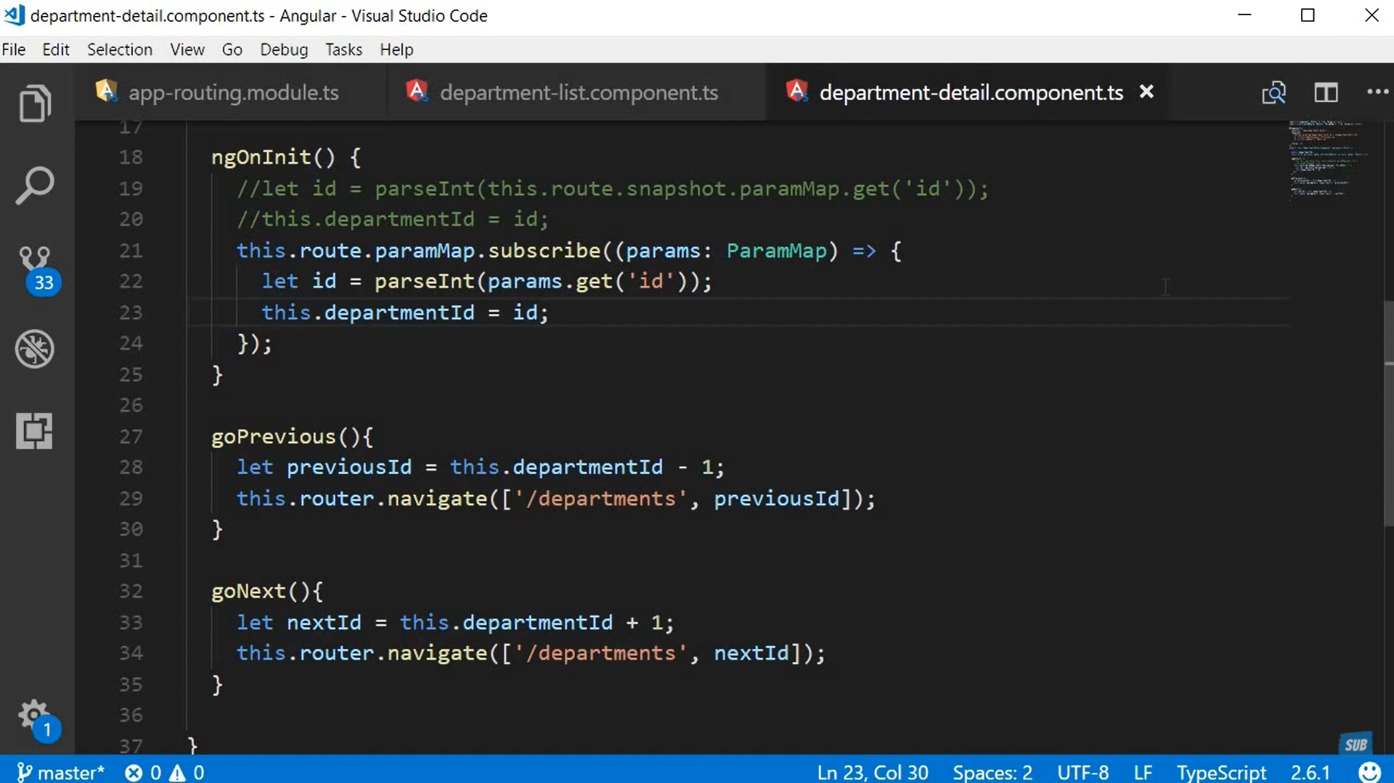

The Id will change , but the view will not change. This is the drawback of snapshot

import { ThrowStmt } from '@angular/compiler';

import { Component, OnInit } from '@angular/core';

import { ActivatedRoute, Router , ParamMap } from '@angular/router';

@Component({

  selector: 'app-department-details',

  template: `

    <h3>

     You have selected {{departmentId}} </h3>

        <a (click)="goNext()"> Next </a>

        <a (click)="goPrevious()"> Previous </a>

  `,

  styles: [

  ]

})

export class DepartmentDetailsComponent implements OnInit {

  constructor(private activatedroute : ActivatedRoute , private router : Router) { }

  public departmentId : number;

  ngOnInit(): void {

  //let id = this.activatedroute.snapshot.paramMap.get("id");

  this.activatedroute.paramMap.subscribe((params) => {

    console.log(params);

    let id=parseInt(params.get("id"));

    this.departmentId = id;

  });

  }

  goPrevious()

  {

  let previousId=  this.departmentId -1;

  this.router.navigate(["/departments", previousId]);

  }

  goNext()

  {

  let nextId=   this.departmentId + 1;

  this.router.navigate(["/departments", nextId]);

  }

}